**OOP Lab04 - Bicycle**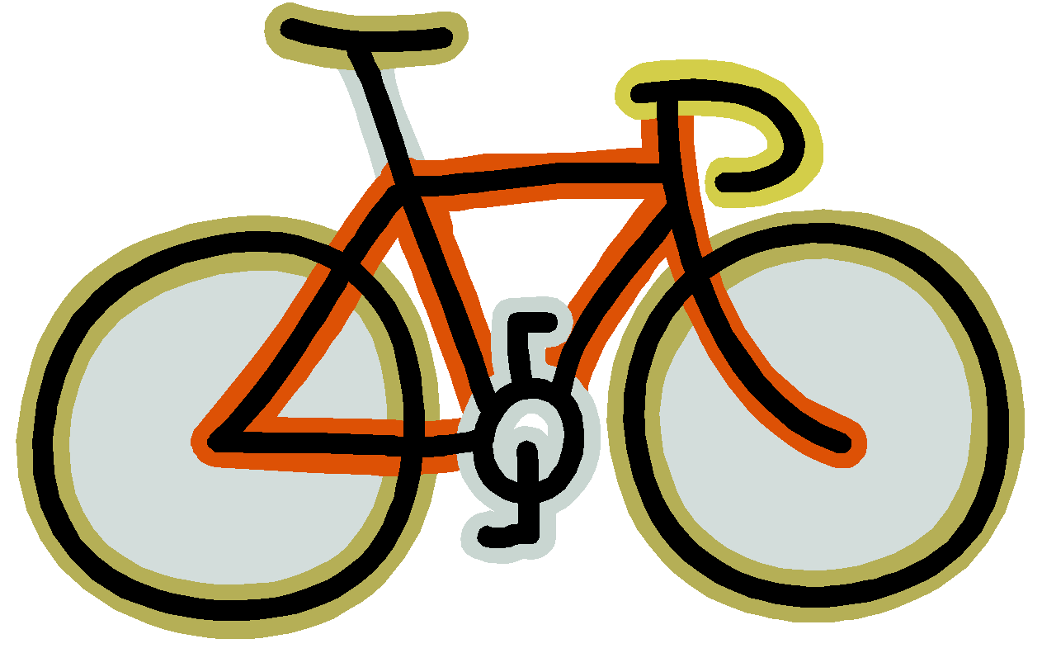



Write a class that will model a bicycle. The Bicycle class has the following:

1. Three instance variables (fields): **Make them private!**

String color //bicycle object’s color

double location//bicycle’s distance from home, in miles

double speed //speed of bicycle, in miles per hour

1. One constructor that takes a single parameter, a String c. The constructor should do the following:

Set the instance variable color equal to the value of the c parameter.

Initializes the location to 0.

Initializes the speed to 0.

1. The following public methods:

public void setSpeed(double newSpeed)

* + - This method takes one parameter, a double newSpeed.
    - It sets its instance variable speed equal to newSpeed.
    - The speed can be positive or negative.
    - This method returns nothing (void).

public void increaseSpeed(double deltaSpeed)

* + - This method takes one parameter, a double deltaSpeed.
    - The bicycle’s speed is increased by deltaSpeed, meaning that deltaSpeed is added to its speed.
    - This method returns nothing (void).

public double travelFarther(double hours)

* + - This method takes one parameter, a double for hours.
    - This method updates the bike’s location, adding additional miles based on the current speed of the bike and the specified number of hours.
    - This method **returns** the number of miles traveled during this time (**not** its current location but how much it changed)

**Hint: You may need to code additional accessors or modifiers to get the Runner to work (See next page)**

After, you’ve written your Bicycle class, test it by making the following class called BicycleRunner:

public class BicycleRunner

{

public static void main(String args[])

{

Bicycle bike = new Bicycle("blue"); // make a new Bicycle object

bike.setSpeed(10);

System.out.println("Color: " + bike.getColor());

System.out.println("Speed: " + bike.getSpeed());

System.out.println("Miles traveled: " + bike.travelFarther((double)3/60)); // 3 minutes

System.out.println("Current Location: " + bike.getLocation());

bike.increaseSpeed(5);

System.out.println("Speed: " + bike.getSpeed());

System.out.println("Miles traveled: " + bike.travelFarther((double)3/60)); // 3 minutes

System.out.println("Current Location: " + bike.getLocation());

}

}

When you run the main()method of the BicycleRunner class, your output should be as follows (if you’ve done everything correctly):

Color: blue

Speed: 10.0

Miles traveled 0.5

Current Location: 0.5

Speed: 15.0

Miles traveled: 0.75

Current Location: 1.25